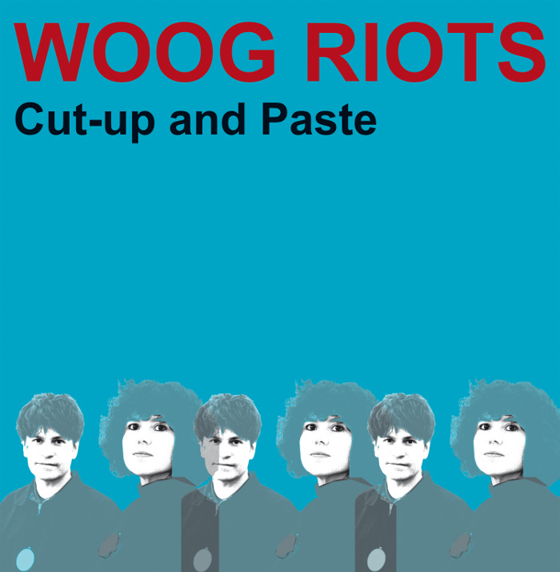
Band: Woog Riots Album: Cut-up and Paste Released March 1, 2019
Label: From Lo-Fi to Disco!
LP+CD / CD digipack / Download (lo-fi 013)
Distributed by Broken Silence
"The Woog is a natural lake in the middle of our city where we like to swim. Then we add the Riots with our lyrics."

The revolution can begin anywhere, in Darmstadt for example. It mustn't sound glossy. The revolution should rattle and simmer with a raw euphoria. 15 years after the band was formed, the name Woog Riots has become synonymous with imaginative and catchy pop songs. Their lo-fi sound and lyrics have a seditious yet deeply human quality. Silvana Battisti and Marc Herbert, the charismatic couple who mastermind the project, have shown that politics and the private, art and attitude, love and revolution as a life concept, can be combined with controversy and good humour.

Their sixth album Cut-up and Paste is no less than a danceable call to arms, to critically question our crazy world, to acknowledge our diverse influences and to bravely rise up against exclusion. In People Reading Marx Woog Riots transfer social criticism to La-La-Land with a laconic swing - without pointing so much as a discofinger. The duo re-interprets the Beatles classic Revolution, transforming it into a cool underground anthem. To All You Racists is a charming protest song of the finest Woody Guthrie singalong tradition, with a cheery invitation to Nazis and their fellow travellers to go away. The Woog Riots' musical and spiritual openness combine in No Borders. This grooving mantra was inpired by astronaut Alexander Gerst, who - when viewing Earth from the International Space Station - stated he could not, with the best effort, recognize any borders. The universe and the dancefloor know no bounds.

With Cut-up and Paste the Woog Riot's express their passion for art in all its diversity. The album title was inspired by a Basquiat exhibition in the Schirn, Frankfurt. Silvana and Marc identify strongly with the work of the New York artist, known for incorporating pieces of other peoples art into his own works: "We take existing snippets of musical heritage and interpret them completely differently. Similar to Hip Hop, except that we don't sample but create everything new." The results are electro-pop collages that do much more than charge the present with a cold beat. The charm of Woog Riots' music lies in its imperfect beauty, in free-purring melodies, in playful minimalism, in garage glam sandwiched between bubblegum and Kraftwerk.

The album was recorded in their living room, reworked and mixed by Lolo Blümler and techno-musician and producer Jörn Elling Wuttke (Alter Ego, Sensorama, Acid Jesus). The diverse elements from which the Woog Riots craft their pop universe are discovered by Silvana and Marc through vivid exchanges with each other and friends, driven by cultural input and political indignation, as well as their experiences on tours from Finland to Japan. This can result in a song like Money Maker, which refers Michael Riedel, the conceptual artist who has created his own currency. In turn Hello Bus Driver goes back to Jim Jarmusch's movie masterpiece "Paterson", promoting neighbourly cohesion as a counter to social decay. The two-part vocals from Marc and Silvana act like an antidote to the autotune trend - close, raw, direct, and immensely warm.

The Woog Riots sound is rooted in Silvana's and Marc's youth: They socialised in the indie pop and post-punk clubs of the Frankfurt Rhine-Main area in the '80s. Discovering Lo-Fi music, in the style of Daniel Johnston and Television Personalities, encouraged the two of them to write songs themselves. Taste guarantor Alfred Hilsberg saw the (initially five-member) band perform in the Knust in Hamburg and went on to release their first three albums with his record company What's So Funny About. The experience gained then prompted Silvana and Marc to found their own label From Lo-Fi to Disco! in 2013.
Whether they're producing a song for Karl Bruckmaier's book The Story Of Pop, or illuminating the activities of whistleblower Edward Snowden on their album Alan Rusbridger - their songs are miles away from the current pop consensus: "Marc is a sociologist and Silvana a Works Councillor. This inevitably results in additional themes for our songs. We want the listeners to be in no doubt about our point of view, there can be no danger of a right wing or neoliberal event using our material as a campaign song!"
Birgit Reuther / Biggy Pop
"An act of genius – Alan Rusbridger the editor on Alan Rusbridger the album", The Guardian, April 18th 2016, Review by Alan Rusbridger
“Early Modern Lovers meets the soundtrack for a Volkswagon commercial.”
Revolver USA Distribution, San Francisco (USA)

“Fun, German/Italian, guy-gal electro-pop duo who betray a fondness for Kraftwerk in the odd robotic vocal. Add Squeeze-esque pop hooks – as in track 'Backstage Lemonade' – to that mix and you'll find yourself bopping along.” Time Out, London (UK)

"...an up-beat, euro-pop dance tune that sounds like a kid’s band version of Kraftwerk with a girl singer. Very fun!" www.worleygig.com (USA)
For more information see www.woogriots.de

